# CS 255 System Design Document Template

## UML Diagrams

### UML Use Case Diagram

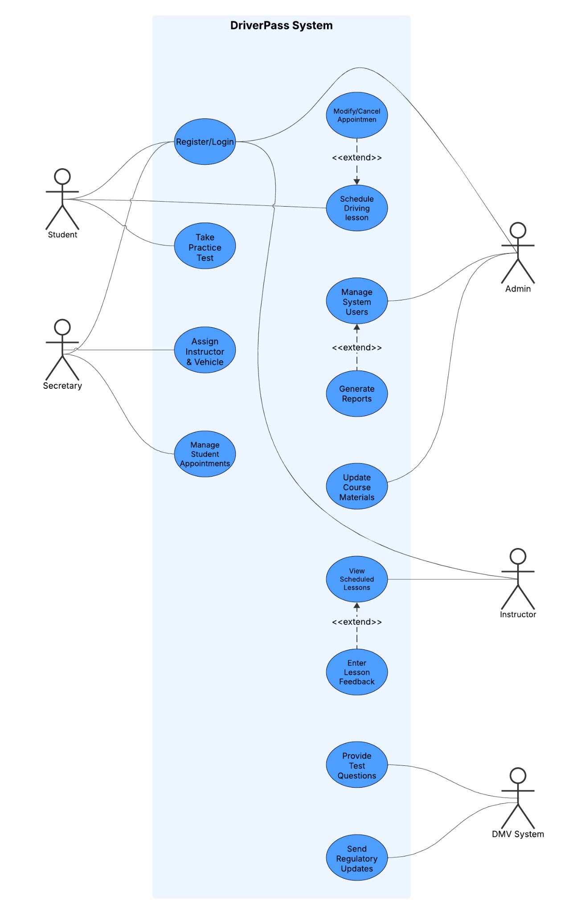

### UML Activity Diagrams

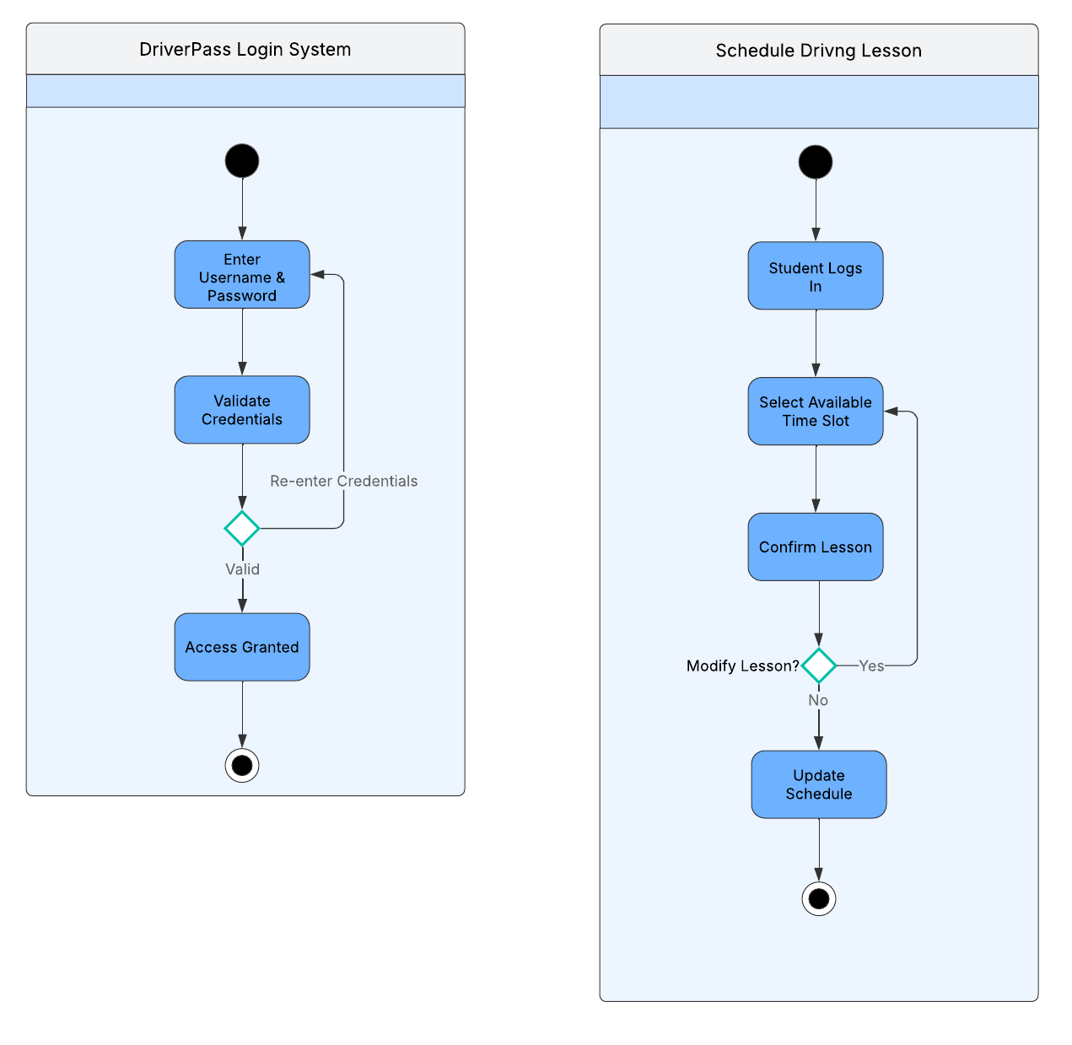

### UML Sequence Diagram

Sequence diagram for scheduling a driving lesson

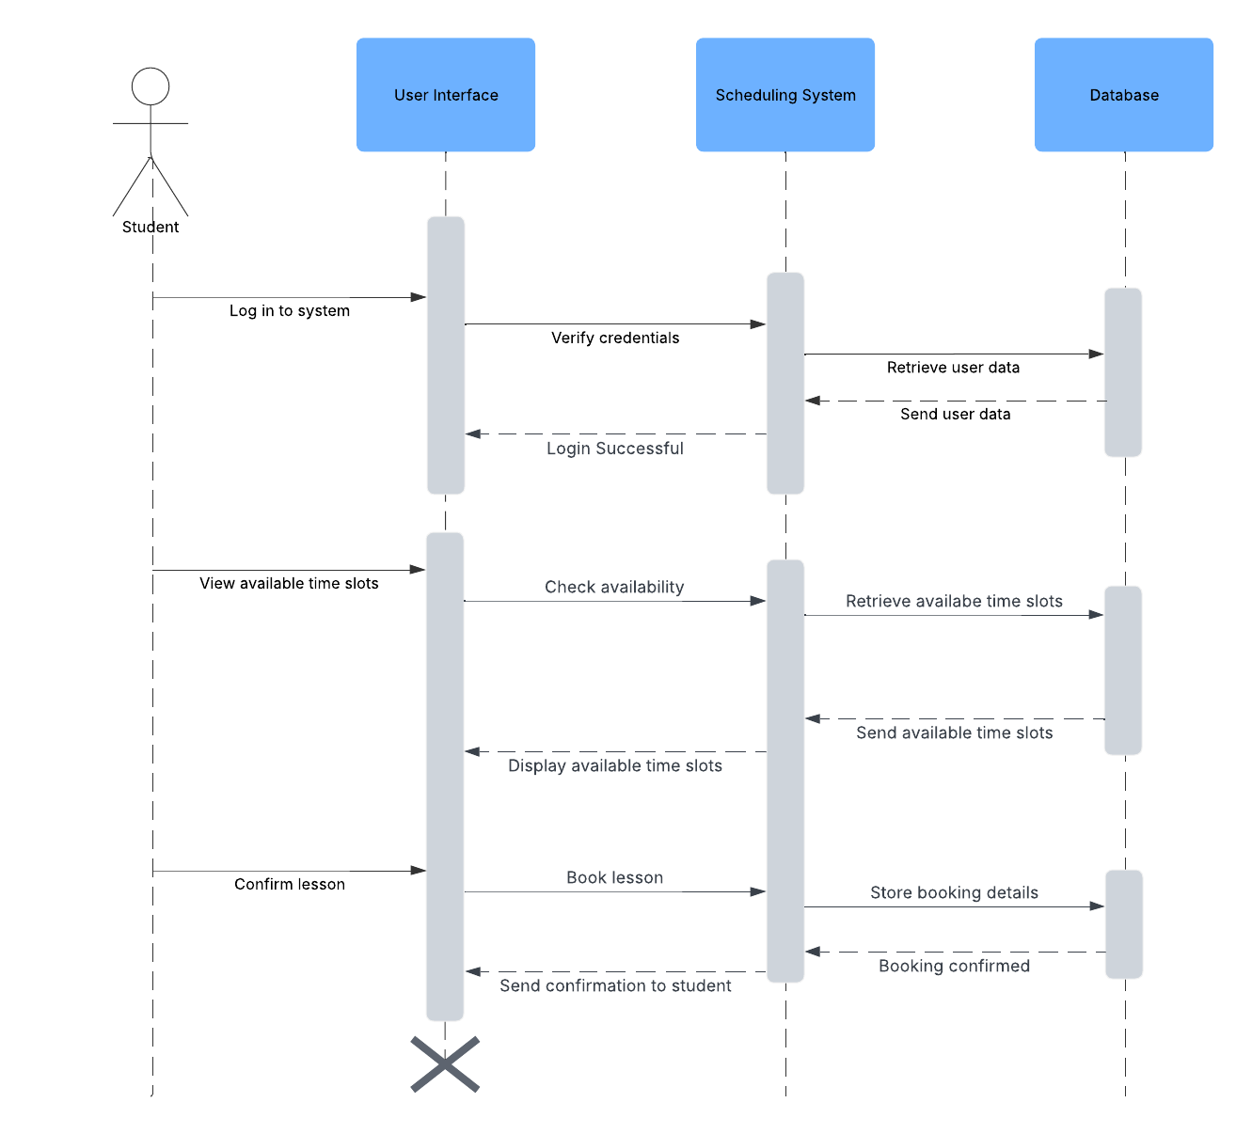

### UML Class Diagram

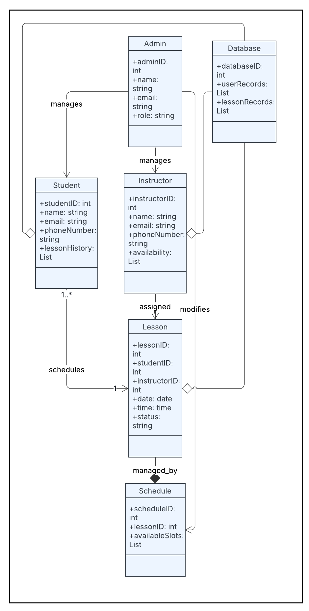

## Technical Requirements

#### **Hardware Requirements**

* **Servers:** The system will need cloud-based or on-site servers to store data and manage schedules.
* **Database Storage:** A system like MySQL or PostgreSQL will be used to save student, instructor, and lesson details.
* **User Devices:** The system should work on computers, tablets, and mobile devices, so it must be designed for different screen sizes.

#### **Software Requirements**

* **Operating System:** The server will run on either Linux (like Ubuntu) or Windows Server.
* **Database System:** A database like MySQL or PostgreSQL will be used to store all system data.
* **Programming Languages:** The system’s backend can be built using Java, Python, or Node.js, while the frontend can use JavaScript with React or Angular.
* **Web Framework:** A framework like Django, Spring Boot, or Express.js will help organize and run the system’s features.
* **Security Measures:** The system will use SSL/TLS encryption to protect data, require logins using OAuth, and have role-based access control so only the right people can access certain features.

#### **Tools & Infrastructure**

* **Development Tools:** Lucidchart will be used for diagrams, GitHub for saving and tracking changes, and Visual Studio Code or IntelliJ IDEA for writing code.
* **Cloud Hosting:** The system will run on a cloud platform like AWS, Google Cloud, or Microsoft Azure.
* **API Integrations:** The system may connect with DMV databases to check information, payment gateways to handle transactions, and email services for sending notifications.